**Assignment No- 13**

**Create a work mail for your organization.**

1. Login into AWS and search Amazon WorkMail then click on organizations then click on create organization select free test domain and give alias name. click on create organization, organization ID and default domain is created.

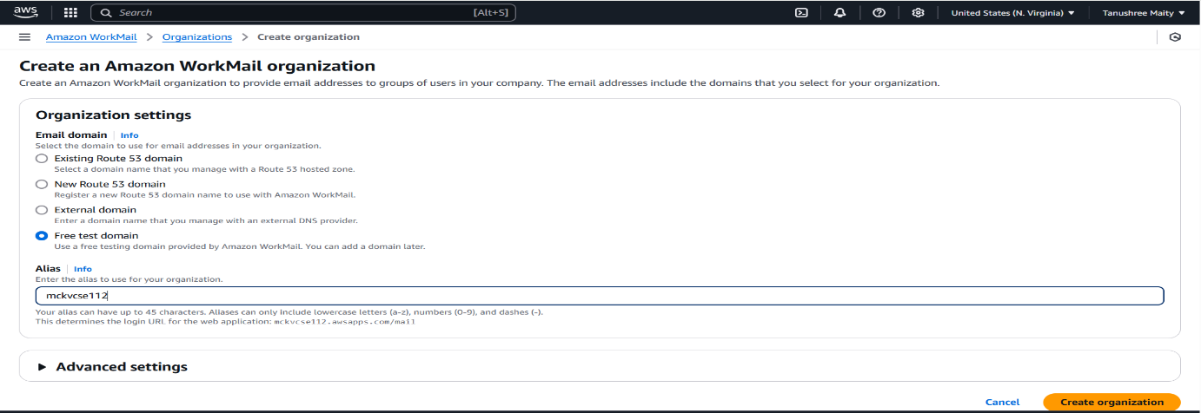

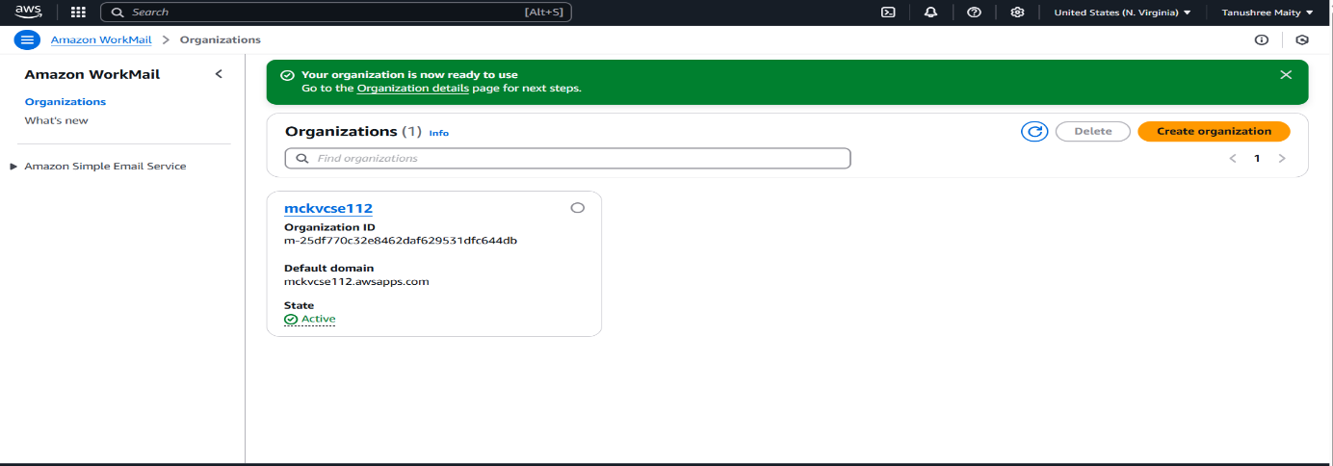

1. Click on organization and create users, give user details and add password setups, after that click on add users. 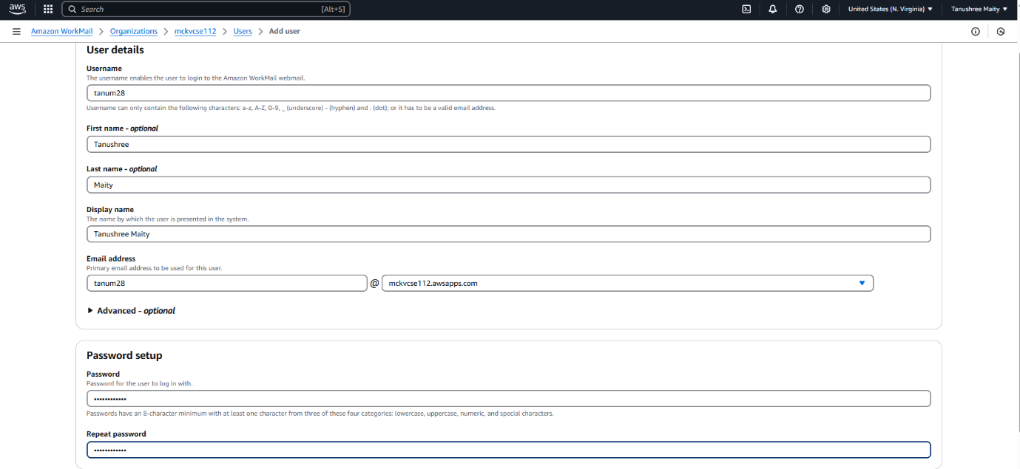

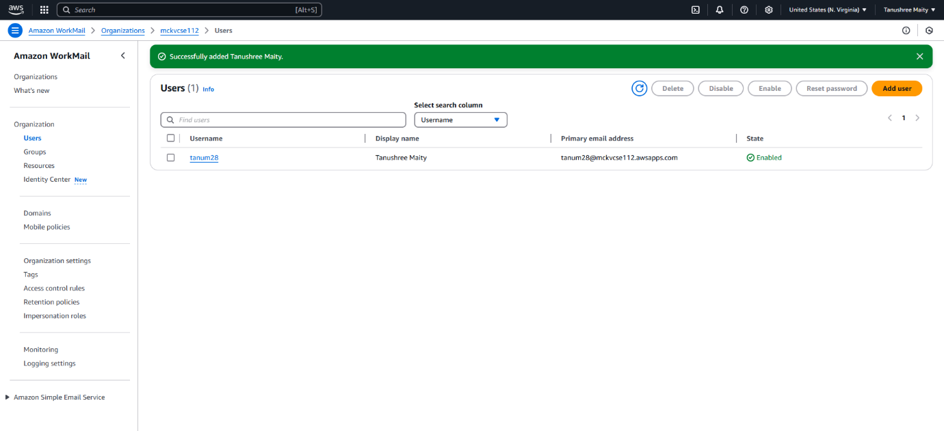

1. Again go to organizations and click on organization name and click on Amazon WorkMail web applications.

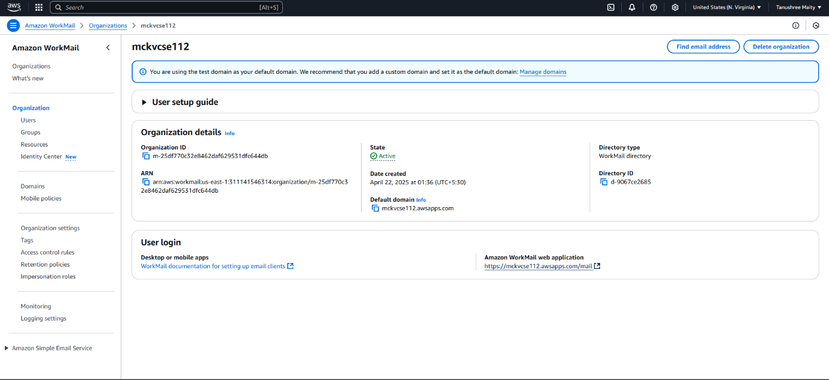

1. After giving username and password, the amazon WorkMail is created.

